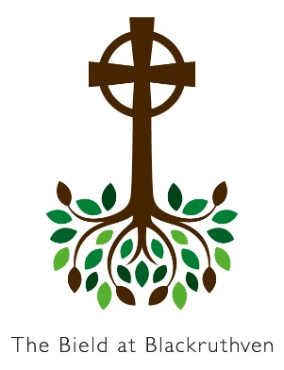

Bield at Blackruthven

Capacitar Wellness Tasters

Facilitated by

Capacitar Trained Bield Staff

The Wellness Practices are simple but effective in healing and self-care. Developed by Dr Pat Cane, founder of Capacitar International, they cover gentle body work and mindfulness practices gleaned and adapted from various traditions. The practices have been used with a variety of people and groups and within different cultures. In a Christian context they can be offered as body prayer and Christfulness (see www.capacitar.org for more information).
Please book through reception at:

info@bieldatblackruthven.org.uk
or 01738 583 238

After booking, please pay the cost in full

See web site for Cancellation Policy
Card payments can be made on the phone.

BACS are Payable to:

The Bield Christian Company Ltd.

Sort Code 83-47-00 A/C 0 0 1 0 0 0 9 5
Please include Surname as ref

www.bieldatblackruthven.org.uk

The Bield at Blackruthven,
Tibbermore, Perth PH1 1PY
The practices help transform stress and pain deriving from illness, violence, and the stresses of daily life and open the individual up towards greater wholeness and wellbeing. As individuals get in touch with their own source of healing and wisdom they can help others.

Facilitators: Capacitar trained Bield staff.

The tasters at the Bield stand alone and give background to Capacitar and introduce a number of practices including:

Tai-chi movements with visualization, Breath-work, Finger Holds for managing emotions, Emotional Freedom Protocol (tapping), head Holds.

There is time for some background information and sharing, questions and comments.

Taster Session Dates

Thurs 15th February 2024 – 9:45am – 12:30pm

Sat 2oth April, 2024 – 2:00pm – 4:30pm

Sat 18th May 2024 – 2:00pm – 4:30pm

Sat 19th October, 2024- 2:00pm – 4:30pm

Cost: £20

If you would like to stay a little longer, you can always book in for lunch, served at 12:30pm
cost £11

The Bield at Blackruthven
Tibbermore
Perth PH1 1PY

Tel: 01738 583 238

www.bieldatblackruthven.org.uk

